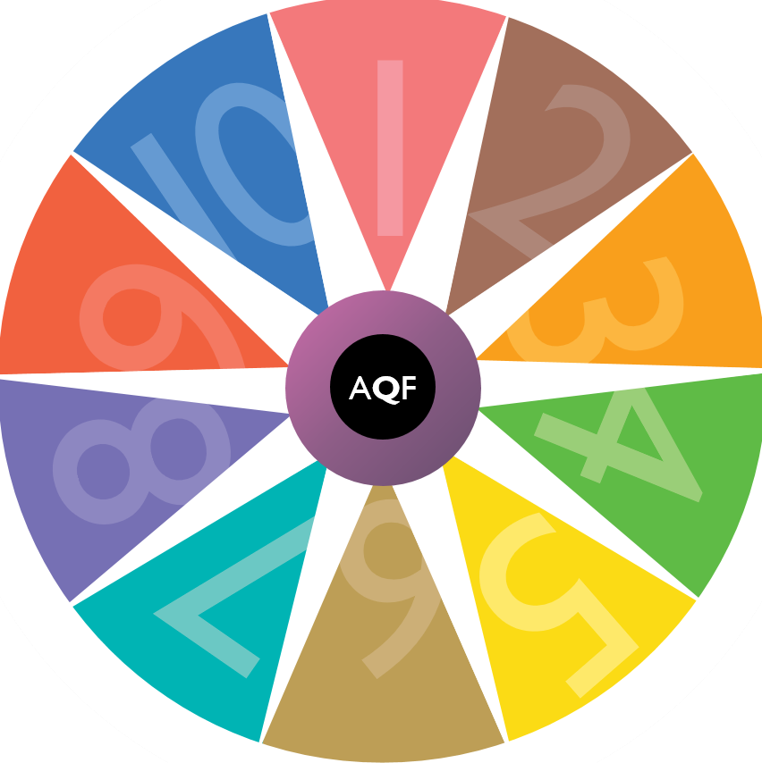

Addendum No. 7 (Part A) to AQF Second Edition January 2013

Vocational Degree Qualification

Addendum No. 7 (Part A) to AQF Second Edition January 2013

Vocational Degree Qualification

Relates to AQF Second Edition January 2013

© Commonwealth of Australia

This work is copyright. You may download, display, print and reproduce this material in unaltered form only (retaining this notice) for your personal, con-commercial use or use within your organisation. All other rights are reserved.

Addendum No. 7 (Part A) to AQF Second Edition January 2013

Vocational Degree Qualification

Education and Skills Ministers (formerly the Council of Australian Governments (COAG) Education and Skills Councils) have endorsed this Vocational Degree qualification addendum to the AQF Second Edition 2013.

This addendum is to be inserted after page 49 of the *AQF Second Edition 2013*.

**Implementation Arrangements**

The Vocational Degree specifications are available for use from the date of Education and Skills Ministers’ endorsement, 17 February 2025.

The Vocational Degree was introduced to the AQF in response to workforce challenges raised in *Working Future: The Australian Government's White Paper on Jobs and Opportunities (White Paper)* and the need to increase advanced skill training at the AQF Level 7 in the vocational education and training sector.

The intention of the Vocational Degree is to provide students with access to work-based learning opportunities at the AQF Level 7, including learning linked with a contract of training. The volume and delivery mode of the work-based learning component of a student’s program of study must align with the standard required for the associated industry.

Education and Skills Ministers will evaluate student and industry satisfaction at an appropriate point to ensure the specification meets policy objectives and is contributing to the *White Paper* response measures.

To support the Vocational Degree’s implementation, the *AQF Qualifications Issuance Policy* has been amendedto incorporate the Vocational Degree and a definition of work-based learning, and contract of training, has been added to the *AQF Glossary*.

This addendum is consistent with the *AQF Qualification Type Additions and Removal Policy*.

**Transition Arrangements**

Issuing organisations that are compliant with the Australian Qualifications Framework Second Edition January 2013 are deemed compliant with this addendum and can use the Vocational Degree specification.

A set of frequently asked questions regarding the amendments can be found on the AQF website www.aqf.edu.au.

AQF Specification for the Vocational Degree Qualification

This *Specification* informs the design and accreditation of Vocational Degree qualifications.

The principal users of the *AQF Qualification Type Specifications* are the accrediting authorities in each education and training sector which are responsible for the accreditation of AQF qualifications and the developers of AQF qualifications in each education and training sector.

The other users of the *Specification*s are the authorised issuing organisations, industry and professional bodies, licensing and regulatory bodies, students, graduates and employers.

The purpose of the Vocational Degree qualification type is to qualify individuals who apply a broad and coherent body of technical and theoretical knowledge, and relevant technical skills, to undertake professional work and as a pathway for further learning.

Vocational Degree qualifications are located at level 7 of the Australian Qualifications Framework.

Vocational Degree qualifications must be designed and accredited to enable graduates to demonstrate the learning outcomes expressed as knowledge, skills and the application of knowledge and skills specified in the level 7 criteria and the Vocational Degree descriptor.



|  |  |
| --- | --- |
| AQF level 7 criteria | |
| **Summary** | Graduates at this level will have broad and coherent knowledge and skills for professional work and/or further learning |
| **Knowledge** | Graduates at this level will have broad and coherent theoretical and technical knowledge with depth in one or more disciplines or areas of practice |
| **Skills** | Graduates at this level will have well-developed cognitive, technical and communication skills to select and apply methods and technologies to:   * analyse and evaluate information to complete a range of activities * analyse, generate and transmit solutions to unpredictable and sometimes complex problems * transmit knowledge, skills and ideas to others |
| **Application of knowledge and skills** | Graduates at this level will apply knowledge and skills to demonstrate autonomy, well-developed judgement and responsibility:   * in contexts that require self-directed work and learning * within broad parameters to provide specialist advice and functions |

|  |  |
| --- | --- |
| Vocational Degree qualification type descriptor | |
| **Purpose** | The Vocational Degreequalifies individuals who apply a broad and coherent body of technical and theoretical knowledge, and relevant technical skills, to undertake professional work and as a pathway for further learning |
| **Knowledge** | Graduates of a Vocational Degree will have a broad and coherent body of technical and theoretical knowledge applied with depth in one or more fields of work and learning |
| **Skills** | Graduates of a Vocational Degree will have:   * cognitive and communication skills to critically review, analyse, consolidate, synthesise and act on information * relevant cognitive and technical skills to demonstrate a broad understanding of knowledge with depth in some areas * cognitive and creative skills to exercise critical thinking and judgement in identifying and solving ill-defined, and unpredictable problems * wide-ranging technical, creative and conceptual skills to communicate concepts to a variety of audiences |
| **Application of knowledge and skills** | Graduates of a Vocational Degree will demonstrate the application of knowledge and skills:   * with initiative and judgement in planning, problem solving and decision making in professional practice * to adapt and apply knowledge and skills in industry practice * with responsibility and accountability for personal outputs and decision-making, and some accountability for the decisions and actions of others within specialised industry contexts |
| **Volume of learning** | The volume of learning of a Vocational Degree is typically 3 – 4 years.  Up to 6 years may be required to achieve the learning outcomes through a contract of training. Learning outcomes for qualifications of this type will be achieved through a combination of institution and work-based learning |



**Qualification nomenclature**

The title used for the Vocational Degree must be consistent with the *AQF Qualifications Issuance Policy*.

**Pathways**

Each qualification accredited as a Vocational Degree will include documented pathways consistent with *AQF Qualifications Pathways Policy.*

Issuing organisations offering a Vocational Degree qualification must meet the requirements of the *AQF Qualifications Pathways Policy.*

**Responsibility for accreditation and development**

Accrediting authorities and those developing qualifications for accreditation must adhere to the AQF specification for this qualification type and any government accreditation standards for vocational education and training when accrediting a Vocational Degree qualification.

Accrediting authorities are responsible for monitoring the quality of issuing organisations against any government regulatory and quality assurance arrangements.

When accrediting AQF Vocational Degree qualifications accrediting authorities must ensure that:

* Graduates of a Vocational Degree qualification will achieve learning outcomes at level 7.
* All the learning outcomes (knowledge, skills and the application of knowledge and skills) of the Vocational Degree qualification type are evident in each qualification accredited as this type. Some may have more emphasis than others in different Vocational Degree qualifications depending on their purpose.
* Generic learning outcomes are explicitly identified in the qualification and align with the level of the qualification type, the purpose of the qualification and the discipline. Generic learning outcomes fall into four broad categories: fundamental skills; people skills; thinking skills; and personal skills.
* The relationship between the learning outcomes in the level 7 criteria, the qualification type descriptor, and the discipline is clear.
* The design of the components of the qualification will provide coherent learning outcomes for the level and qualification type and will enable graduates to demonstrate them.
* The volume of learning is sufficient for graduates to achieve the learning outcomes for a qualification of this level and type. Learning outcomes for qualifications of this type will be achieved through a combination of institution and work-based learning.

**Authority to issue the qualification**

A Vocational Degree qualification may only be issued by an organisation that is authorised by an accrediting authority to do so and meets any government standards for the sector.

Assessment leading to the award of the qualification lies with the issuing organisation. The issuing organisation is responsible for ensuring the quality of the learning outcomes and that the graduate has satisfactorily completed any requirements for the awarding of the qualification.

Issuing organisations must issue qualifications consistent with the *AQF Qualifications Issuance Policy*.

Issuing organisations will maintain a register of the AQF qualifications they have issued consistent with the *AQF Qualifications Register Policy*.

